Quantamental Context Engine (QCE): A lightweight Graph-Based Context-Aware AI Backbone for hedge fund workflows
Alpha Context Engine (ACE), Investment Context Engine (ICE), Context Graph (CG)

1. Executive Summary
Investment professionals are inundated with information – from portfolio data and watchlists to a flood of sell-side research emails and market news. Lean, traditional hedge funds face a disadvantage when competing against larger investment firms with greater resources. The proliferation of third-party AI tools, combined with democratization of cutting-edge large language models (LLMs) present a clear opportunity: lean hedge funds must become AI-ready to tap onto these tools to harness its potential and level the playing field with industry giants.
The Investment Context Engine (ICE) is a modular, lightweight AI system designed to serve as the cognitive backbone of a hedge fund’s core workflows—spanning idea generation, equity research, portfolio monitoring, risk management, and investor communications.
ICE integrates and encodes both external financial data (e.g., filings, news, earnings transcripts) and internal firm sources (e.g., research notes, emails, portfolio holdings) into a unified, compounding knowledge graph (KG) that continuously encodes the hedge fund’s DNA, mental models and investing philosophy. This KG structure enables multi-hop reasoning and long-term memory which is queried through a graph-aware retrieval-augmented generation (Graph-RAG) pipeline, processed by a monolithic but extensible agentic layer that is designed to be compatible with external Model Context Protocol (MCP)-based tools, databases, and models.
By combining structural graph context with semantic retrieval, ICE grounds large language models (LLMs) in the most relevant and complete firm-specific knowledge—enabling explainable, traceable, decision-ready answers. This accelerates and improves investment reasoning, aligns decision-making across teams, and builds a compounding knowledge asset that delivers sharper insights and more informed decision-making across different investment functions.
[Incorporate 2 example queries]

2. Problem Statement
Modern equity research and portfolio management depend on synthesizing insights from an ever-expanding range of fragmented sources: earnings calls, SEC filings, market news, broker reports, internal research notes, emails, and price action. For lean boutique hedge funds, this process remains largely manual and disjointed—heavily reliant on human memory, speed, and judgment—placing them at a competitive disadvantage to larger funds with specialized teams, advanced infrastructure, and scalable systems.
This fragmentation creates four critical pain points:
- Delayed signal capture: Analysts may miss soft signals or early narrative shifts buried in transcripts, filings, or news flows. PMs and traders often react to events with latency or incomplete context.
- Low insight reusability: Investment theses, observations, and research remain siloed in decks, chats, or emails—rarely rediscovered or built upon across time and teams.
- Inconsistent decision context: Different team members interpret or prioritize information inconsistently, leading to fragmented understanding and reactive, uncoordinated decisions.
- Manual triage bottlenecks: Stitching together context from disparate data sources remains a fully manual task, limiting both speed and scale.
Despite a wave of AI products entering the investment domain, most remain generic. Off-the-shelf language models surface market-consensus insights rather than reflecting a fund’s unique mental models, thesis structures, or interpretations of risk. Their outputs are often static and disconnected—useful in isolation, but unlinked to institutional memory or compounding insight. At the same time, frontier models like ChatGPT have become powerful and widely accessible. But raw model capability is no longer the differentiator. The real challenge lies context engineering, in applying these models effectively—by tailoring an information-dense context that is complete, current, and aligned with the hedge fund’s proprietary knowledge, investment logic, and the user’s specific query. This engineered context can then serve as the anchor that grounds frontier LLMs—allowing them to reason across structured and unstructured signals, deliver explainable and traceable outputs, and generate responses that reflect the way the firm actually thinks.
This addresses the build-or-buy dilemma clearly: Build the “spine” (ICE), buy the muscles (third-party AI solution or databases). For a small fund, outsourcing core cognitive infrastructure means ceding control over how investment logic is represented and remembered. Instead, a lightweight in-house system that integrates firm-specific knowledge and enables modular interoperability with external tools (via standards like MCP) offers a more cost-effective, extensible, and defensible path forward.
Larger hedge funds solve this with dedicated functions, well-funded teams, and mature tooling. Boutique firms, however, face structural constraints on talent, bandwidth, and integration capacity—yet are equally exposed to the same information deluge. ICE addresses this asymmetry by acting not as another tool, but as the fund’s systemized memory, reasoning engine, and knowledge flywheel—growing more useful with every query, document, or insight added.

3. Proposed Solution: Investment Context Engine (ICE)
The Investment Context Engine (ICE) is a modular, lightweight AI system that engineers high-quality context by combining fragmented external data (e.g. earnings transcripts, filings, news) with internal firm knowledge (e.g. research notes, investment memos, emails and portfolio holdings information). Functioning as a dedicated context assembler for investment workflows, ICE structures informations to ground the output of frontier LLMs in the firm’s proprietary insights and ensuring every generated answer is not just relevant, complete and up-to-date, but deeply aligned with the fund’s investment philosophy and processes.
In ICE, the context is a structured composition of relevant facts (internal and external), signals and documents pulled from both the knowledge graph and the semantic vector store, tailored to the query and aligned with the fund’s investment logic. In short: firm-specific reasoning memory + fresh semantic evidence fused into one coherent input.
Context assemble involves two components:
- Short-term context: User’s query + Recent chat history
- Long-term context: Retrieved subgraph from KG
ICE is a modular system that combines four key components:
- Knowledge Graph: Encodes relationships between companies, events, analysts, metrics, and narratives.
  - Check out Smithery (MCP libraries)
- Graph-RAG: Instead of retrieving raw text snippets, GraphRAG traverses the KG to contextually expand queries before retrieval, improving answer relevance. Then, an LLM agent dynamically navigates the graph, deciding which nodes/edges to explore next, mimicking human-like reasoning by iteratively refining heuristic search. Finally, the frontier LLM synthesizes answers using both the retrieved subgraph and its inherent reasoning capabilities. Relationships in the graph provide explicit logical structure, reducing the risk of hallucinations.
- Monolithic Agent System: Simple triage model with Extractor, Reasoner, and Synthesizer agents.
- Model Context Protocol (MCP): Standardizes message passing between agents in a structured, interpretable format.
At its core is a domain-specific knowledge graph (KG) that integrates both external financial data (e.g., earnings transcripts, filings, news) and internal firm knowledge (e.g., research notes, investment memos, portfolio holdings). This graph encodes key relationships — such as narrative linkages, KPI drivers, causal chains, and soft signals — aligned with the fund’s unique mental models and investment logic.
Queries to ICE—such as “Why did stock price of ABC fall post-earnings?” or “What companies are exposed to the EV subsidy narrative?”—are handled through a graph-aware retrieval-augmented generation (Graph-RAG) pipeline. ICE retrieves relevant nodes, paths, and documents from the graph and vector database, then passes that structured context to a monolithic agentic layer that simulates the triage logic of a human analyst: extract → reason → synthesize. The result is an explainable, traceable response grounded in the firm’s own mental models and context. Unlike SaaS tools or LLM wrappers that focus on access or summarization, ICE is purpose-built to reflect the fund’s unique investment processes and cognitive lens. It is MCP-compatible by design, enabling plug-and-play interoperability with future third-party tools, models, or internal systems.
Over time, ICE becomes the fund’s cognitive operating layer—a reusable infrastructure that encodes, evolves, and surfaces how the firm reasons about information and data. It transforms every research cycle into a contribution to institutional memory and enables faster, more consistent decision-making with each use.

Key Components
Component | Value Proposition | Simplicity & Maintainability
Knowledge Graph | Encodes relationships between entities, enabling multi-hop reasoning, long-term memory, and alignment with investment logic. | Built using familiar tools like NetworkX or Neo4j; schema evolves modularly with the fund’s logic.
Graph-RAG | Contextually expands queries by traversing the KG and retrieving semantically relevant evidence. Improves relevance and grounding of answers (reduces hallucination) | Lightweight Graph-RAG wrapper using FAISS + graph traversal; easy to extend with heuristic search.
Monolithic Agent | Simulates analyst triage logic (extract → reason → synthesize) in a unified flow for traceable and explainable outputs. | One orchestrated agent; no inter-agent complexity. Easy to debug, iterate, and evolve over time.
MCP (Model Context Protocol) | Plug-and-play protocol for AI ecosystems | Optional in MVP
Streamlit UI | Provides an intuitive front-end for PMs and analysts to query ICE, review outputs, and visualize reasoning trails. | Low-code, fast, lightweight frontend

Knowledge Graph Construction
The conceptual design of the KG would involve meaningful queries that a fundamental-based equity hedge fund would ask. The consolidated categories of queries would then determine the Typed Edge Patterns that forms the unified KG.
the Typed Edge Patterns in MVP Solution:
Typed Edge 1 | Causal Link Edges
Typed Edge Pattern | [Node: Event] (Typed Edge: likely_impacts) [Target Node: Company/Metric]
Purpose | Capture causal links between regulatory, corporate, company-specific events and their downstream effect on a company’s key operating and financial metrics.
Example | [Taiwan earthquake] → (likely_impacts) → [TSMC revenue]  [Fed rate hike] → (likely_impacts) → [Mortgage originations]
Business Value | Allows forward scenario modelling + LLM reasoning
Example Query | “What companies are exposed if X happens?”

Typed Edge 2 | Narrative Clusters or Story Threads
Typed Edge Pattern | [Node: Company] (Typed Edge: part_of_narrative) [Target Node: Theme/Event]
Purpose | Map companies to evolving market narrative/themes
Example | [Nvidia] → (part_of_narrative) → [AI Infrastructure Buildout]  [Tesla] → (part_of_narrative) → [EV Regulation Tailwinds]  [Apple] → (part_of_narrative) → [Supply Chain De-risking]
Business Value | Narrative drives multiple expansion or contraction. This helps structure unstructured sentiment into a graph for thematic baskets or risk hedging.
Example Query | “Which tickers are part of the generative AI narrative?”  “Which companies are riding on the China de-risking story?”

Typed Edge 3 | Anchor KPIs or “Economic Driver” Links
Typed Edge Pattern | [Node: Company] (Typed Edge: key_driver) [Target Node: Metric]
Purpose | Capture the 1-2 core KPIs that drive valuation for a firm; bridges qualitative statements to valuation-sensitive metrics.
Example | [Meta] → (key_driver) → [DAUs]  [Airbnb] → (key_driver) → [Nights booked]  [UPS] → (key_driver) → [Avg fuel cost]
Business Value | When paired with time series or forward expectations, this gives the KG a valuation grounding
Example Query | “Which firms will be affected by falling ad CPMs?”

Typed Edge 4 | Soft Signal Linkage
Typed Edge Pattern | [Node: Company] (Typed Edge: has_soft_signal) [Target Node: Soft Signal Event]
Purpose | Add a lightweight node for “soft signals” that LLMs or heuristics can pick from new news or filings
Example | o [Disney] → (has_soft_signal) → [Layoffs in Streaming Division]  o [AMD] → (has_soft_signal) → [Delayed chip launch]  o [Alibaba] → (has_soft_signal) → [Exec reshuffling]
Business Value | Soft signals often precede hard data (like earnings hit). Easy to extract, and great for GraphRAG-based scenario Q&A.
Example Query | “”

Typed Edge 5 | Peer Similarity Link
Typed Edge Pattern | [Node: Company A] (Typed Edge: business_model_similarity) [Target Node: Company B]
Purpose | Construct economic similarity graphs – not just sector, but business mechanics.
Example | o [Shopify] ↔ [BigCommerce]  o [Datadog] ↔ [New Relic]  o [Unity] ↔ [Roblox]
Business Value | Useful for relative value, peer comps, and thematic risk hedging.
Example Query | “If Company X has poor earnings, who else might miss their earnings expectations?”

Typed Edge 6 | Earnings Surprise Signature
Typed Edge Pattern | [Node: Company] (Typed Edge: surprise_direction) [+ / -] + Edge to prior cause
Purpose | Use LLMs to extract explanations for earnings beat/misses and connect them to metrics/products.
Example | O [Netflix Q2 2024] → (surprise_direction) → [+]  - → (due_to) → [Password crackdown in LatAm]  - → (affects) → [Subscription growth]
Business Value | Let us do pattern mining on beat/miss causes and build predictive priors for next earnings.
Example Query | “”

4 different layers of semantic logic, each layer made up of typed edges, all part of the same unified graph, not separate graphs:

Each edge type functions as a semantic layer within the graph, allowing LLMs and humans to traverse meaningfully and reason over structured market intelligence. This design transforms the KG into a multi-layered cognitive map—a true representation of how the fund sees and interprets markets.
When constructing the KG, should we incorporate both qualitative and quantitative information? Or should we just use the qualitative information to construct the KG, then use tool-calling to call the appropriate quantitative information?
Data Infrastructure
Data Type | Source | Cost | Notes
10-Ks, 10-Qs | EDGAR | Free | Use EDGAR APIs or sec-edgar-downloader
Earnings transcripts | SeekingAlpha, Yahoo, AlphaSense | Free → $ | Can extract free ones or sample via API
News / Events | RSS feeds, Financial News APIs | Free → $ | Can add paid feeds later
Supply chain data | Public filings, LLM extraction | Free | Don't need full FactSet SC
Internal data | Emails, Analysts notes, Emails | Free | High-value and defensible
Third-party research | SeekingAlpha, SmartKarma, Substack | Paid
Alt-data (optional) | SimilarWeb, LinkedIn, etc. | $–$$$ | Add later once ROI is proven
Data
- Hedge fund portfolio holdings (internal data); Emails; Analysts writing
- Analysts reports
- Factset API
- News API
- Finbert (other finance corpus/LLM)
- 10Ks, transcripts, investors presentation, earnings transcripts, earnings announcements.

Technical Infrastructure
Component | Tool / Option | Cost | Purpose
Graph DB / Engine | NetworkX (simple), or Neo4j, ArangoDB (prod) | Free → $ | Store and query your knowledge graph
Document Store | Chroma, Weaviate, or even JSON/CSV + LangChain | Free | Store raw + processed corpora
LLM API | OpenAI (GPT-4), Anthropic (Claude), open models (Mixtral) | $50–$500/mo | Extract triples, reason over graph
Data pipeline | LangChain, LlamaIndex, Airflow (optional) | Free | Coordinate LLM workflows
Compute | Local or light cloud (Colab, EC2, Lambda) | Low | LLM calls + graph ops are lightweight
Frontend (optional) | Streamlit, Dash, Jupyter | Free | Graph queries or visual UI
File storage | S3, local FS | Free → $ | Store filings, transcripts, embeddings

LLM and NLP Tooling
Use Case | Tool | Notes
Triple extraction | GPT-4 or Claude | Prompted over 10-Ks, transcripts
NER / entity linker | spaCy, Flair, LLMs | Helps identify companies, KPIs, events
Graph reasoning | GPT-4 + LangChain agent or KG-QA | Answer queries using KG paths
Prompt chaining | LangChain, Guidance | Enable multi-hop logic
Optional QA bots | LangChain + Chroma + KG | For internal query interfaces

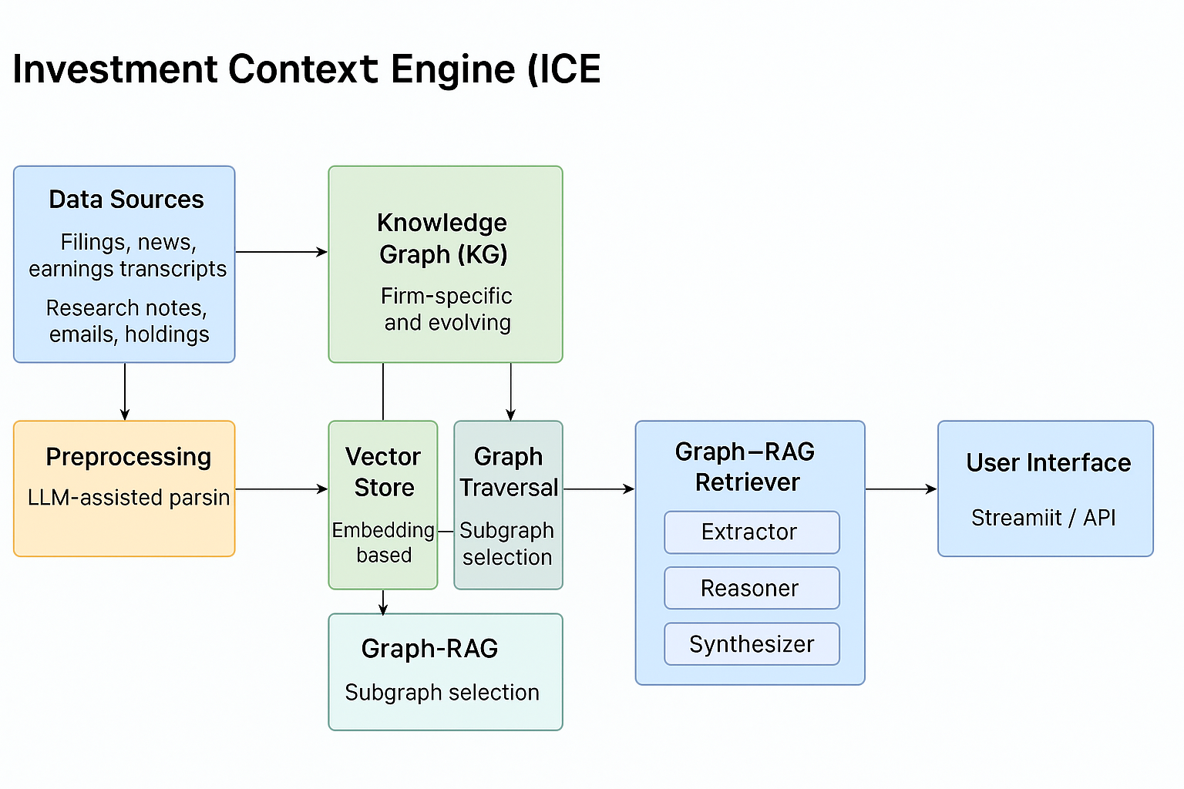

Feasibility Analysis
MVP score and timeline.
S&P 500 universe.
Selected queries group to address in MVP.
Phased execution of product.
Constraints: Token limits. IT constraint. Knowledge and expertise constraint. Time constraint.
Advances in open-source LLMs, vector databases, innovative graph design tooling make it possible for a small team to build a custom, lightweight reasoning layer. Combined with agentic frameworks and MCP-style modularity, ICE can be deployed by a single quant within 4 months – delivering hedge-fund-grade cognitive infrastructure without requiring expensive enterprise stacks or AI teams.
Time & Effort Breakdown (Lean MVP)
Task | Duration
Data scraping/setup | 1-month
Graph schema design | 3 weeks
Graph construction (NetworkX/Neo4j) | 1 week
LLM pipeline for triple extraction | 2 weeks
Graph query interface (basic) | 2 weeks
RAG / LLM | 4 weeks
Monolithic Agent / MCP | 3 weeks
GRAG Evaluation | 2 weeks

Business value
There comes a Build-or-buy dilemma for the small hedge fund. In current times and times ahead, there will be exploding number of AI-solutions which hedge fund can tapped on. As such, we need a system/backbone in place to connect to these AI tools.
The main focal point of this AI solution is to provide the best context for SOTA LLM to best answer the user’s queries. Foundation LLMs often have blackout information, while most of possible hedge fund queries may tend to require most up-to-date information to make informed decision. Additionally, this solution allows for internal data to sharply enhance the context for more firm-specific queries to be answered. The knowledge graph layer further […], that compounds over time that becomes more ingrained with the fund’s dna.
The Solution: Investment Context Engine (ICE)

Core Components

Overview Architecture
Data Sources → KG Builder → Graph-RAG Retriever → Agents (Extractor → Reasoner → Synthesizer) → Streamlit UI
Each component is modular and swappable, lightweight and low-cost, future compatible with MCP.
Possible Tech Stack
Build the raw edge lists that powers everything in the knowledge graph.
- Triple Extraction Prompt Engineering: Design prompts for an LLM (e.g. GPT-4) to extract (subject, predicate, object) tiples from unstructured financial text.
- Classify edge types (e.g. causal, narrative, KPI anchor, etc)
- Ensure extractions are compact, consistent and usable for populating the KG.
UI
Feasibility study and plan of action
- List the constraints of this project
- Scope
- Minimal Viable Architecture
- Describe plan of action -> execute in phrases, each with its business value already present
Future plans
- Multi-agentic workflow: Triage logic of research analysts through components like Extractor, Reasoner and Synthesizer agents. These agents interact with the KG and retrieval layer to deliver tailored, explainable and traceable outputs for analysts and PM workflows.
- Trades information internal data

